Zoom Instructions and Best Practices for Participants and Session Chairs:
ICSOS 2022 will use Zoom as the conference platform. Please make sure you have access to this platform before the start of the conference.

Initial Zoom setup:
Please install Zoom in advance.

Access to the Session(s):
Upon registration to the conference, a confirmation email with the access code to the protected program zoom links will be provided. Please enter the access code to view the zoom links for your registered sessions.

During the Session(s):
- Each Zoom Webinar Room will be opened 30 minutes before the start time. This time is available for any presenters that need to test their presentation. Please send a message to the room host for further instructions and/or questions.
- All Presenters and Session Chairs will be elevated to “panelist” upon entering the zoom webinar room on their assigned session time. Please send a message to the room host for any questions.
- All participants, excluding the Presenters, will be muted throughout the entire session. Please note that we will be using Zoom Webinar and all participants will be muted automatically upon entering the room. Please send a message to the room host for any questions or concerns.

How to Ask Questions

Option 1: Chat
You can join the discussion with other attendees by sending messages to “Everyone” or you can chat privately with the Session Chair by selecting their name from the drop down list. Learn more about Using Webinar Chat.
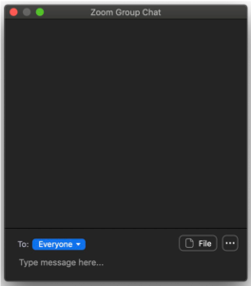

Option 2: Q&A Session
Following the author presentation there is a short Q&A session.
We request participants to use Q&A panel on the side-panel on the right of the Zoom window. If not shown, one can click on the icon to enable the Q&A panel.
You can post your questions in the Q&A window anytime during the Session. If you need to refer to the presentation, please indicate clearly the section of within the slides. If there is no page number available, please note down the time of the relevant content.
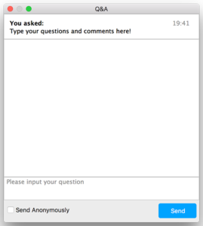
At the end of the talk, the Session Chair will select and ask the presenter to answer some of the questions in sequence they were submitted and within the allotted Q&A period and will try to cover as many questions as possible depending on the allotted time.

Breaks:
Conferencing, online and in-person can be exhausting! We need to take breaks. Breaks are built-in to the schedule!
- Stand up and stretch, get a snack, come back refreshed!
- (Presenters) If you leave Zoom on, please make sure that your microphone is muted during the break.

